How to open play ground labs to access the jump box

<https://labs.play-with-docker.com/>

Click on Login->docker

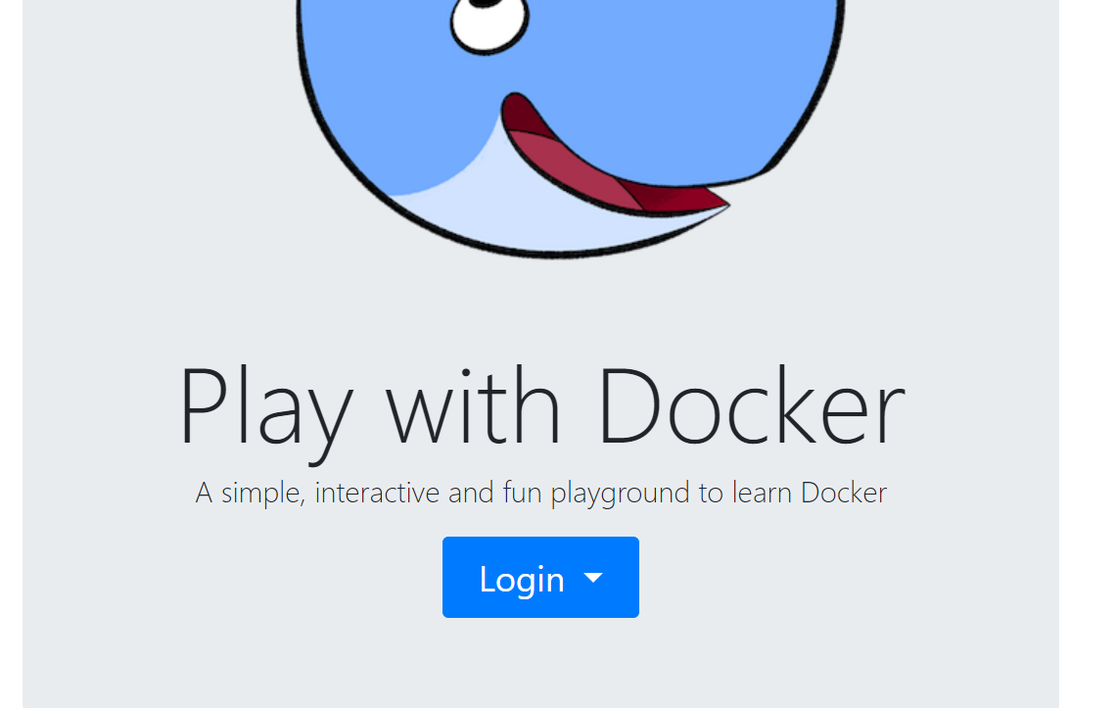

Click on Continue with github

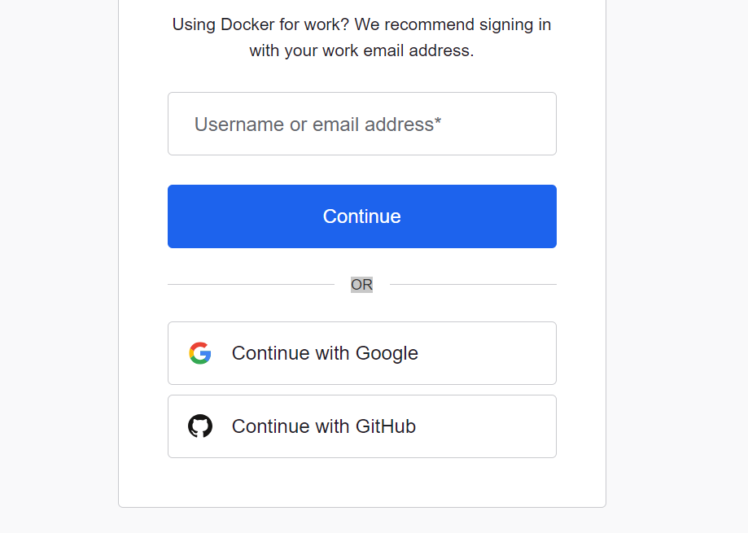

Click on start

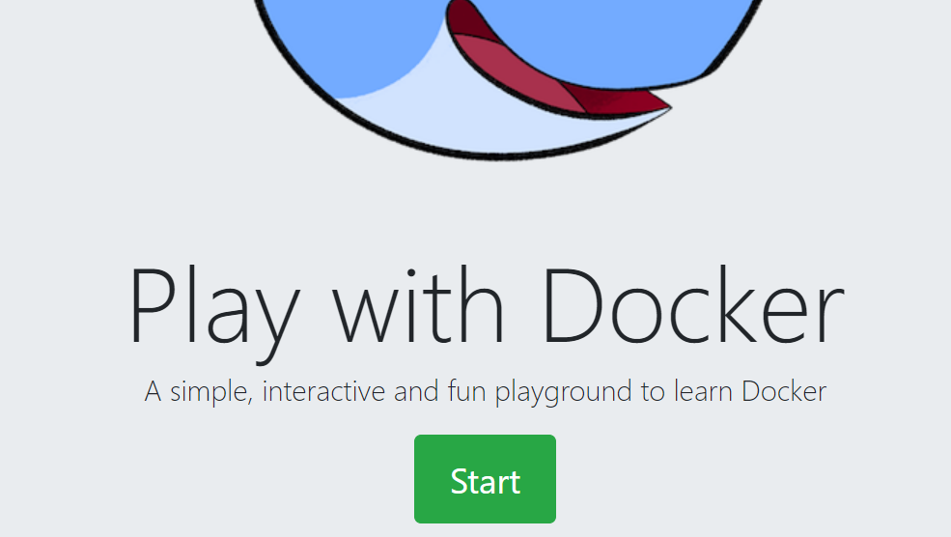

Click on add new instance

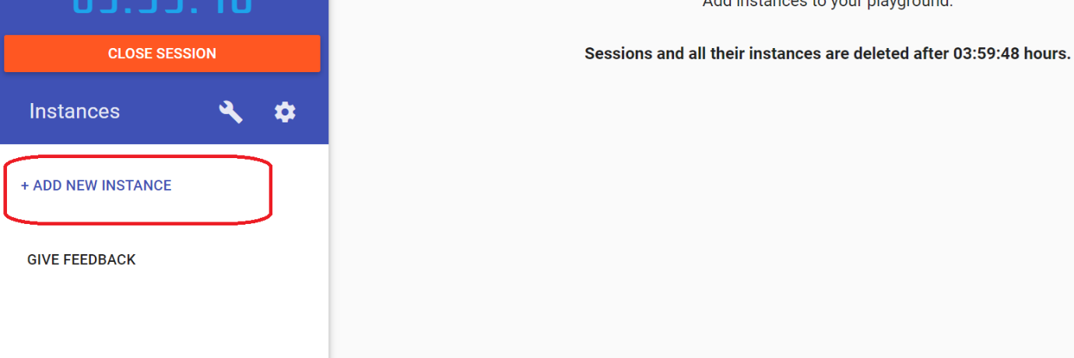

Trainer will provide the pem file/ you must received over mail as well

Using vi editor, copy the pem file

vi stage.pem

save it

chmod 600 stage.pem

ssh -i stage.pem ec2-user@<ip address provided by trainer>